Technical Design Document

Synthetic Data Generation Using Local LLM

Version: 1.0
Author: Satvik Sharma
Date: 25-08-2004

Revision History

Date | Version | Description | Author
2026-25-08 | 1.0 | Initial version | Satvik Sharma

Table of Contents
1. Introduction
1.1 Purpose of this document
1.2 Intended Audience
1.3 Scope
1.4 Definitions and acronyms
1.4.1 Definitions
1.4.2 Acronyms and abbreviations
2. General overview
2.1 Technologies used
2.2 General functioning
2.3 Error handling
3. Technical requirement
3.1 Client requirement
3.2 Server Requirement
3.3 Google map API
4. Source structure
5. Architecture
5.1 High Level Architecture
5.2 Component Diagram
5.3 Data Generation Flow
6. Database Relationship Management
6.1 Schema Discovery
6.2 Dependency Graph
6.3 Parent Child Processing

7. Security Considerations

8. Future Enhancements

9. References

Introduction

Purpose of this document

The purpose of this document is to describe the design, architecture, implementation approach, and technical details of the Synthetic Data Generation System based on a Local Large Language Model (LLM).
The system automatically analyzes database schemas, understands table relationships, generates realistic synthetic data, and populates the target database while maintaining referential integrity.
.

Intended Audience

The intended audiences are:
• Technical Leads
• Architects
• Developers
• Project Managers
• Future Maintenance Teams

Scope

This document covers:
- Schema discovery
- Relationship analysis
- Dependency management
- Synthetic data generation
- Local LLM integration
- JDBC-based database insertion
- Parent-child relationship handling

Definitions and acronyms

Definitions

Keyword | Definitions
Synthetic Data | Artificially generated data that resembles real data
Schema | Structure of database tables and columns
Dependency Graph | Representation of table relationships

Acronyms and abbreviations

Acronym or  abbreviation | Definitions
LLM | Large Language Model
PK | Primary Key
FK | Foreign Key
JDBC | Java Database Connectivity
DI | Dependency Injection
JSON | JavaScript Object Notation

General overview

Technologies used

The system uses the following technologies:
- Java 17+
- Spring Boot
- JDBC
- Local LLM
- MySQL/Oracle/PostgreSQL
- Jackson JSON Parser
- Maven

General functioning

The system performs the following operations:
- Connects to the database.
- Reads database metadata.
- Identifies table relationships.
- Builds dependency hierarchy.
- Sends schema information to local LLM.
  - Generates synthetic records.
  - Maintains table dependencies.
  - Inserts generated data into database.
  - Validates generated data.

Error handling

The system follows layered exception handling.
Each service captures exceptions and propagates meaningful errors to upper layers.
Examples:
- Database connection failures
- Invalid LLM responses
- Constraint violations
- Batch insertion failures
- Foreign key violations

Technical requirement

Client requirement

• Web Browser
• API Client (Optional)

Server Requirement

• Java 17+
• Spring Boot Runtime
• Database Server
• 16GB+ Memory Recommended

LLM Requirements

• Local LLM Deployment
• API Accessibility
• JSON Response Support
• Structured Prompt Support

Source structure

src/main/java
│
├── controller
│
├── service
│ ├── SchemaReaderService
│ ├── RelationshipAnalyzerService
│ ├── DependencyGraphService
│ ├── LlmService
│ ├── DataGeneratorService
│ ├── ValidationService
│ └── DataInsertionService
│
├── model
│
├── repository
│
├── utility
│
└── config

Architecture

Architectural design consisted of high-level architecture and detail design including sequence diagrams and class diagrams.

High Level Architecture
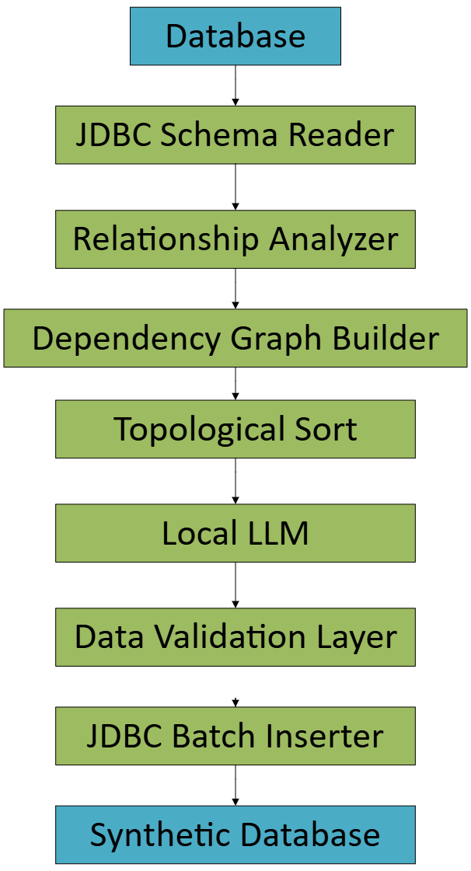

Figure 1: High level architecture of SDG

Component Diagram
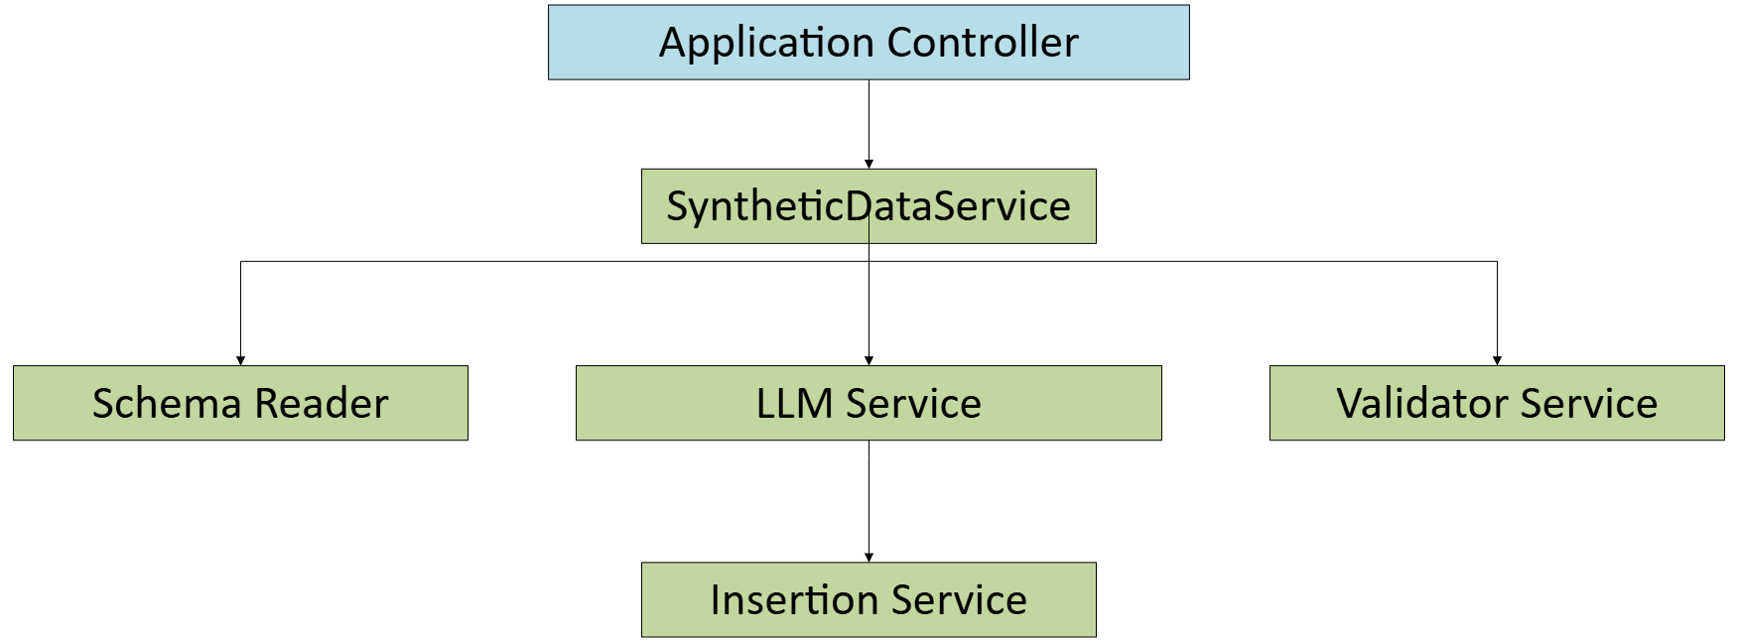

Figure 2: Simplified SDG Component Diagram

Data Generation Flow
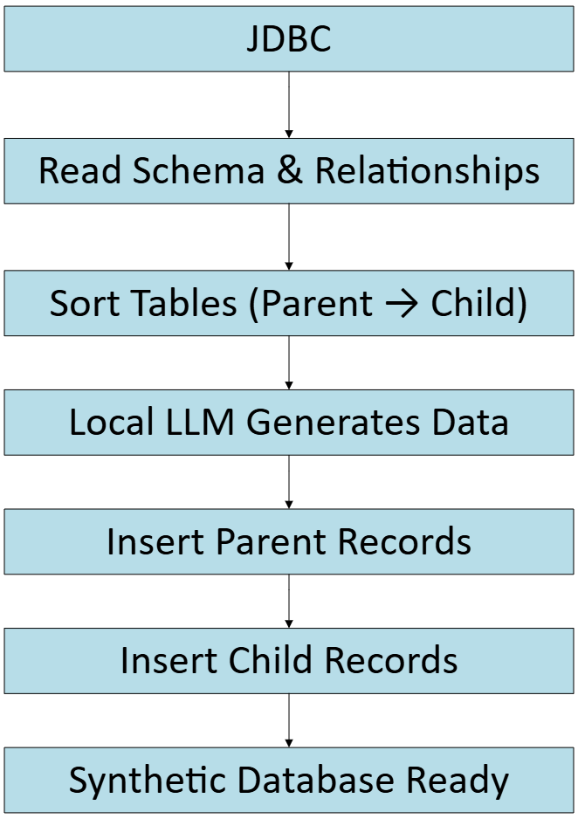

Figure 3: Data Generation Flow

Flow Explanation
- Read Schema & Relationships
Reads tables, columns, primary keys, foreign keys, constraints, and dependencies.
- Sort Tables
Computes parent-child ordering to maintain referential integrity.
- Local LLM Generates Data
Generates realistic records based on schema metadata.
- Insert Parent Records
Populates independent tables first.
- Insert Child Records
Populates dependent tables using valid parent key references.

Database Relationship Management

Schema Discovery
Database metadata is extracted through JDBC:
- Tables
- Columns
- Data Types
- Primary Keys
- Foreign Keys

6.2 Dependency Graph
A dependency graph is built using PK-FK relationships.
Purpose:
- Identify dependencies
- Determine insertion sequence
- Maintain referential integrity

Parent Child Processing
The system follows:
- Generate parent table records.
- Store generated primary key values.
- Generate child records.
- Assign valid foreign key references.
- Insert records following dependency order.

Security Considerations

Local LLM deployment.

No external API communication.

Secure database credentials.

Role-based access control.

Audit logging.

Encrypted database connections.

Controlled schema access.

Future Enhancements

Multi-database support.

User-configurable record counts.

REST API support.

Web dashboard.

Parallel data generation.

Data quality scoring.

Multi-LLM support.

Export to CSV/JSON formats.

References

Spring Boot Documentation

JDBC API Documentation

Java Language Specification

Database Vendor Documentation

Local LLM Integration Documentation

Internal Project Guidelines

